Year 5
 | Term 1 |  | Term 2 |  | Term 3 |  | Term 4 |  | Term 5 |  | Term 6
Progression of Core Texts | 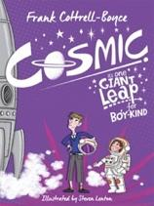  Cosmic |  | 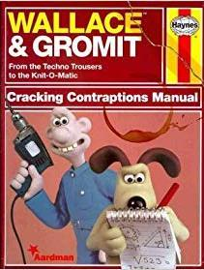  Wallace & Gromit: Cracking Contraptions |  | 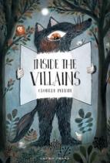  Inside the Villains |  | 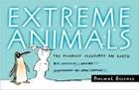  Extreme Animals |  | 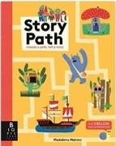  Story Path |  | 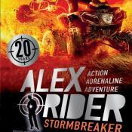  Myth Atlas
Read aloud book | Teacher to decide |  | Teacher to decide |  | Teacher to decide |  | Teacher to decide |  | Teacher to decide |  | Teacher to decide
Links to Wider Curriculum | Space (Tim Peake) |  |  |  | Adventure (Sir Ranulph Fiennes) |  |  |  | Romans (Spartacus)
Enrichment | Visit Plymouth museum |  | Visit Wolsey centre |  | Visit River Dart |  | Visit Paignton Zoo |  | Visit Exeter Museum |  | Theme day/Dress as a Roman day
Independent purposeful writing outcomes | To Compose an email from one character to another |  | Devise and write about your own cracking contraption to create a class Haynes Manual |  | To (re)write a traditional style fairy tale featuring a chosen character |  | To write own book about a range of items/objects |  | To create own story path around a story blueprint |  | To write a diary entry
Grammar and punctuation | - Choosing nouns and pronoun appropriately  - Noun phrases expanded by the addition of modifying adjectives  - Using fronted adverbials and using commas after fronted adverbials  - Using relative clauses |  | - Using Modal verbs  - Using Adverbs  - Use expanded noun phrases with pose and pre modification  - use passive verbs to affect presentation of information in a sentence |  | - using brackets, dashes or commas to indicate parenthesis  - Using expanded noun phrases  - linking ideas across paragraphs using adverbials of time, place and number or tense choices |  | - Using expanded noun phrases to convey complicated information concisely  - Using the perfect form of verbs to mark relationships of time and cause |  | - using modal verbs (e.g. might, should, will, must) or adverbs (e.g. perhaps, surely)  - using relative clauses beginning with who, which, where, when, whose  - relative pronoun  - using commas to clarify meaning or avoid ambiguity in writing |  | - Link ideas across paragraphs using adverbials of time [for example, later], place [for example, nearby] and number [for example, secondly] or tense choices [for example, he had seen her before]  - Verb prefixes  - Converting nouns or adjectives into verbs using suffixes
Spelling | No Nonsense Spelling Programme

