Year 6
 | Term 1 |  | Term 2 |  | Term 3 |  | Term 4 |  | Term 5 |  | Term 6
Progression of Core Texts | 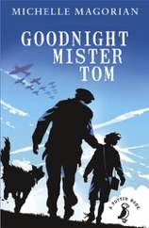  Goodnight Mister Tom |  | 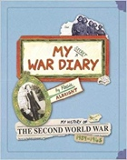  My Secret War Diary |  | 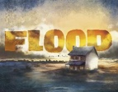  Flood |  | 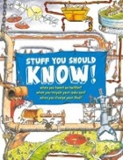  Stuff You Should Know |  | 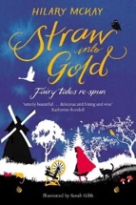  Straw into Gold: Fairy tales re-spun |  | 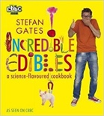  Incredible Edibles
Read aloud book | Teacher to decide |  | Teacher to decide |  | Teacher to decide |  | Teacher to decide |  | Teacher to decide |  | Teacher to decide
Links to Wider Curriculum | (Nancy Wake) |  |  |  | (Amelia Earhart) |  |  |  | (Ibn Battuta)
Enrichment | Visit Dartmoor Air raid shelters |  | Visit Bygone museum in Torquay |  | Visit the Naval aviation museum |  | Visit Plymouth Museum |  | Theme day |  | Cook off day
Independent purposeful writing outcomes | To write a missing chapter/ alternative ending to Goodnight Mr Tom |  | To write a sequence of diary entries linked to a period in history |  | To write the story of Flood |  | To write an explanation about how something works |  | To write a retelling of a well-known fairy tale but alter this in some way |  | To write a concise set of instructions based on a product designed
Grammar and punctuation | - Use relative clauses  - Use model verbs  - Use adverbs  - Use brackets, dashes and commas  - Use expanded noun phases  - Understanding Synonyms and Antonyms |  | - use a range of sentence constructions  - standard English forms for verb inflections instead of local spoken forms  - the difference between structures typical if of informal speech and structures appropriate for formal writing  - Recognising subjunctive forms |  | - using passive verbs to affect the presentation of information in a sentence  - using expanded noun phrases to convey complicated information concisely  - using relative clauses  - using a colon to introduce a list  - using semi-colon within lists  - Bullet points  - Recognising vocabulary and structures that is appropriate for formal speech and writing, including subjunctive form |  | - Using semi-colons to mark boundaries between independent clause  - Use of the colon to mark the boundary between independent clauses  - Use of the dash to mark the boundary between independent clauses  - Using hyphens to avoid ambiguity |  | - Revision from previous years to address the Writing objectives re: selection and authorial choice to create settings, character and atmosphere: listing phrases and clauses (compounding, coordinated clauses Y2); adverbials (Y3/4); noun phrases - pre- and post-modification (Y2-6) and vocabulary choice.  - SAT assessments |  | - Consolidation (Key Stage 2)  - Coverage of all KS2 Grammar, Vocabulary and Punctuation objectives.
Spelling | No Nonsense Spelling Programme

