Year 4
 | Term 1 |  | Term 2 |  |  | Term 3 |  | Term 4 |  | Term 5 |  | Term 6
Progression of Core Texts | Gregory Cool |  | 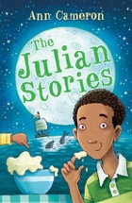  The Julian Stories b |  |  | 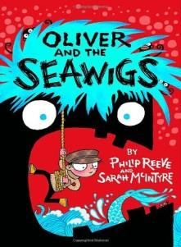  Oliver and the Seawigs |  | 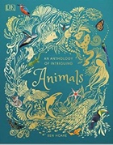  An Anthology of Intriguing Animals |  | 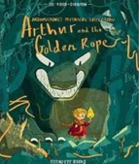  Arthur and the Golden Rope |  | 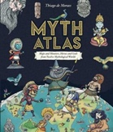  Myth Atlas
Read aloud book | Teacher to decide |  |  |  |  | Teacher to decide |  |  |  | Teacher to decide
Links to Wider Curriculum | Explorer (Levison Wood) |  |  |  |  | (Kira Salak) |  |  |  | (Leif Erikson)
Enrichment | Walk over Dartmoor to gain inspiration |  |  | Theme day to dress up as famous explorers |  | Trip to the local lake |  | Trip to the local beach |  | Visit Exeter museum |  | Theme day dressed as Vikings
Independent purposeful writing outcomes | To write a story based on the blueprint of the book |  |  | To write a class book of new Julian stories in chapters with each child writing a chapter on the theme of brothers and sisters |  | To write a story from a different view point. |  | To write an information text about 3 different animals organised in a specific way |  | To write a non-chronological report such as a newspaper report |  | To write a myth based on one of the characters from one of the cultures in the book
Grammar and punctuation | - Use the forms a or an according to whether the next word begins with a consonant or a vowel  - Extend the range of sentences with more than one clause, using a wider range of conjunctions.  - Introduction to inverted commas to punctuate direct speech  - Use of the present perfect form of verbs instead of the simple past |  |  | - Choosing nouns or pronouns appropriately for clarity and cohesion and to avoid repetition  - Appropriate choice of pronoun or noun within and across sentences to aid cohesion and avoid repetition  - Using fronted adverbials  - Using commas after fronted adverbials |  | - Revise using the present perfect form of verbs instead of the simple past tense  - Indicating possession by using the possessive apostrophe with plural nouns  - The grammatical difference between plural and possessive –s  - Apostrophes to mark plural possession  - Using and punctuating direct speech |  | - Use of inverted commas and other punctuation to indicate direct speech  - Noun phrases expanded by the addition of modifying adjectives, nouns and preposition phrases  - Appropriate use of pronoun or noun within and across sentences to aid cohesion  - Revisit suffixes |  | - Using fronted adverbials  - Using commas after fronted adverbials  - Indicating possession by using the possessive apostrophe with plural nouns  - Standard English forms for verb inflections instead of local spoken forms [for example, we were instead of we was, or I did instead of I done]  - Use of paragraphs to organise ideas around a theme |  | - Extending the range of sentences with more than one clause by using a wider range of conjunctions, including when, if because, although  - Choosing nouns or pronouns accurately for clarity and cohesion and to avoid repetition  - Spell using the suffix –ation  - Spell using the suffix –ly  - Spell using the suffix –ous
Spelling | No Nonsense Spelling Programme

