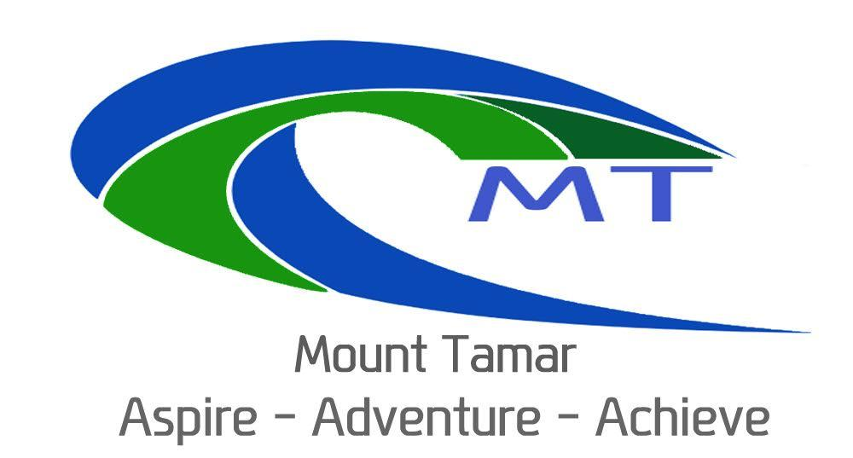
Mount Tamar School

Prevent Policy

Version Control
Policy Prepared by: Chris Holl
Document Name | Meeting Submitted | Summary of Changes | Date for next Review
Prevent Policy | SLT January 2016 | New policy | Spring 2018
Prevent Policy | SLT January 2018 | No changes | Spring 2020
Prevent policy | SLT April 2020 | Minor changes updated in section 26 - 3 strands | Spring 2022

Prevent Policy
This policy recognises that extremism and Prevention of radicalisation is broadly a safeguarding issue.
As with all child protection, we will follow the requirement to refer to Children’s Social Care appropriately where the child is at risk or in need, due to extremist behaviours and/or influences.
We have a Prevent Duty policy and reference is made to the Prevent duty in appropriate other Mount Tamar policies.
As a Respecting Rights of our children, we believe all children have a fundamental right to be protected from harm. All children have a fundamental right to expect Mount Tamars to provide a safe and secure environment. We have a legal and professional duty and responsibility for keeping them safe.
We will help support pupils who may be vulnerable to such influences as part of our wider safeguarding responsibilities and where we believe a pupil is being directly influenced by extremist materials or influences, we will ensure the pupil is offered mentoring. We will seek external support from the Local Authority, the Police, and/or local partnership structures working to prevent extremism.
However, staff at Mount Tamar School will be alert to the fact that whilst extremism and radicalisation are broadly a safeguarding issue there may be instances where a child or children may be at risk of direct harm or neglect. For example, this could be due to a child displaying risky behaviours in terms of the activities they are involved in or the groups they are associated with, or staff may be aware of information about a child’s family that may equally place a child at risk of harm. {This example is illustrative and not exhaustive].
Therefore all adults working at Mount Tamar School, including visiting staff, volunteers, contractors, students on placement, guest speakers or those adults the children come in contact with on trips, are required to report instances where they believe a child may be at risk or harm or neglect to the Designated Safeguarding Lead or Head teacher, including any harm through extremism or radicalisation.
The new Counter-Terrorism and Security Act 2015 contains and places a legal duty on specified authorities and public bodies which includes schools to have “due regard to the need to prevent people from being drawn into terrorism.” This is also known as the Prevent duty. This is found in Sections 26 and 29. It is backed by statutory guidance which is monitored by Ofsted through their existing inspection procedures. It builds on the 2002 and 2011 Prevent strategy. All staff have received WRAP training.
Mount Tamar School have a duty to educate children to be tolerant whilst protecting those who may be at risk of racial hatred or vulnerable to radicalisation.

Section 26 of the Counter Terrorism Act 2015 states that Mount Tamar should pay:

‘Due regard to the need to prevent people from being drawn into terrorism.’
‘Being drawn into terrorism includes not just violent extremism but also non-violent extremism
and can popularise views which terrorists exploit.’

Mount Tamar School has a duty “…to forbid political indoctrination and secure a balanced presentation of political issues.”
The 2011 Prevent strategy has three specific strategic objectives:
- respond to the ideological challenge of terrorism and the threat we face from those who promote it
- prevent people from being drawn into terrorism and ensure that they are given appropriate advice and support
- work with sectors and institutions where there are risks of radicalisation that we need to address.

These duties are imposed on maintained schools by sections 406 and 407 of the Education Act 1996.
It is our school’s duty to ensure children are safe from a range of views which are extremist and seek
to radicalise them, therefore, our staff have had training to be confident with the skills to handle
these issues. Our children need to understand that Mount Tamar is a safe place for informed debate
and the School Parliament will work on this.

We teach the children through:
- PSHE/Citizenship/RE/SMSC/English/History and British values links, the skills to empower children to think critically so as to understand and tolerate difference, especially of other faiths and of no faith.
- Discussions will take place in a safe and secure way.

The Government has defined extremism in the Prevent strategy as:
Extremism is...
‘Vocal or active opposition to fundamental British values, including democracy, the rule of law,
individual liberty and mutual respect and tolerance of different faiths and beliefs. We can also
include in the definition of extremism, calls for the death of members of our armed forces.’

Racial Hatred and Radicalisation
Radicalisation is...
‘The process by which a person comes to support terrorism and extremist ideologies associated with
terrorist groups.’
Mount Tamar has a duty to educate children to be tolerant whilst protecting those who may be at risk of racial hatred or vulnerable to radicalisation.

It sets a range of expectations on Mount Tamar School:-
Staff will:
1. be alert to possible signs of extremism
2. Use their professional skills, instincts and judgements
3. Follow existing safeguarding procedures
4. be balanced, proportionate and reasonable
5. Notice-issues of concern
6. Check-with other colleagues/agencies
7. Share-concerns via the safeguarding procedures in a professional manner
Every member of staff has a duty to understand and identify children at risk of radicalisation.
Your Prevent Champions are Chris Holl, Kim Wentworth (through safeguarding processes) and Carrie King (through youth services and community links).
These staff members are you first point of contact and will deal with any aspects of communication as well as use of the Channel reporting procedures.

Signs and Risk Factors
This is not a catch all check list but we have used the e-safetysupport.com check list for anti-
Radicalisation.
Disclosures may be in the form of writings, drawings, possessing or accessing extremist materials.
Expressions of support for terrorism may be using extremist narratives and the “us and them”
language, justifying the use of violence to solve real or perceived grievances.

Personal crises put children at risk. These may be family tensions, sense of isolation, low self-esteem, and changes in friendship groups, searching for answers to questions about identity, faith or belonging.
Similarly personal circumstances such as migration, local community tensions and events affecting the child’s country or region of origin, a sense of grievance triggered by personal experience of racism or decimation or aspects of government policy.
Mount Tamar School will:
- Understand that Prevent is pre-criminal and does not have to be proven beyond reasonable doubt. Not all extremism leads to terrorism.
- Teach a broad and balanced curriculum, and will debate “difficult” issues through dialogue.
- Promote fundamental British values, staff will examine schemes of work under Britishness and seek opportunities to make links.
- Staff can challenge which is not the same as “spying” and have a duty to whistle blow if appropriate.
- Risk assess the likelihood of pupils being drawn into terrorism and support for extremism.
- Work in partnership.
- Train staff to give them the confidence, knowledge and skills to identify children at risk.
- Have robust IT policies which protect children from terrorist and extremist material when accessing the internet at Mount Tamar.
- Monitor effectively and ensure robust safeguarding policies are in place to identify children at risk, intervene and refer pupils as appropriate.
- Report any concerns.

The Governors will act as critical friend and will have “due diligence” in monitoring the activities and curriculum of Mount Tamar.

Accessing Material Online and propaganda online
- Violent extremists use propaganda to spread their ideology and provide religious or moral justification for acts of terror and violence around the world.
- The majority of propaganda is spread online nowadays with extremists using social networking sites as their main recruiting tool.

Mount Tamar School will endeavour to educate students and stakeholders by:-
- Strengthening community cohesion.
- Discussing major world events.
- Enabling children to become active citizens
- Increasing the religious knowledge and understanding of staff.
- Educating children about different religions.
- Helping children to critically evaluate online material.

The Current situation, Britishness and extremism

Radicalisation and Counter Extremism relates to it in all its forms-international terrorism, left and right wing extremism, and so is not only Islamic extremism.
The most significant of these threats is still currently from terrorist organisations in Syria, Libya and Iraq, with Al Qaida associated groups.
But terrorists associated with the extreme right also pose a continued threat to our safety and security. The white supremacist ideology of extreme right-wing groups has also provided both the inspiration and justification for people who have committed extreme right-wing terrorist acts. People can become self-radicalised through Facebook and other social media networks.

Islamist extremists regard Western intervention in Muslim-majority countries as a ‘war with Islam’, creating a narrative of ‘them’ and ‘us’. Their ideology includes the uncompromising belief that people cannot be both Muslim and British, and that Muslims living here should not participate in our democracy.
Islamist extremists specifically attack the principles of civic participation and social cohesion. These extremists purport to identify grievances to which terrorist organisations then claim to have a solution.
The strategy also means intervening to stop people moving from extremist (albeit legal) groups into terrorist-related activity.

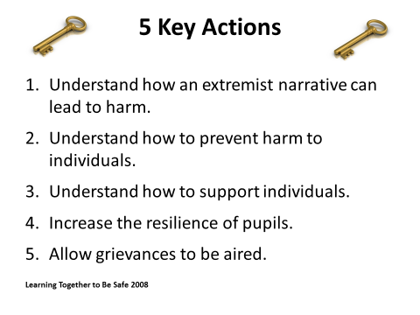

Keeping Children Safe in Education-2015 has implications for following the duty on Mount Tamar in the exercise of their function to have due regard to the need to prevent people from being drawn into terrorism. The Counter Terrorism and Security Act 2015 also places a duty for Channel Panels to be in place. We, as a school will cooperate with partners in the panel in the discharge of its function in identifying and assessing the extent to which individuals are at risk of being drawn into terrorism and the support provided to those individuals.
Appendix
Channel is a voluntary referral process/pathway and is a programme offered to the subject, but the children or parents can decline, can be referred without parent knowledge. It encourages a discussion of controversial and sensitive issues. There is a legal, democratic and safe way to challenge government policies so this act doesn’t limit opposition. The local Authority, Police counter-terrorism have undertaken a risk assessment known as the Local profile, but it is restricted in circulation.
Police can be contacted on 999 for cases of immediate and serious risk of harm through terrorism. Otherwise 101 or prevent@ devonandcornwall.pmm.police.uk can be contacted.
660713 Committee for Family and Cultural Diversity. Peter.aley@plymouth.gov.uk
Channel Procedure 